# Winding Things Down in Europe

America - I'm coming for you!!!! And I can't wait!!!

This was a nice and relaxing week here in Aviano, Italy. I stayed in a B&B just down the street from Benson and Kylie, and every day I got to choose what to do - or not do. No pressing structure or schedule, just whatever and whenever I wanted.

(Sorry this photo of Benson and me is a little blurred . . .)

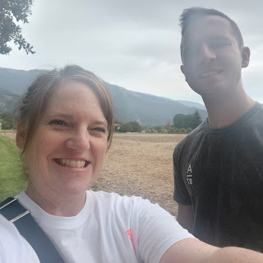

The field at the end of the lane by their house, and looking toward the Dolomites.

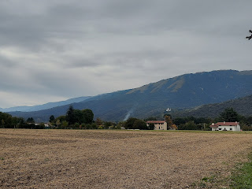

Monday:

I left Bassano del Grappa, land of my ancestors and the place where I fulfilled my childhood dream of flying. I rode my last train, traveling from Bassano to Pordenone, where Kylie was there to pick me up. Everything went really smoothly on this day, which was a huge relief. Especially after the craziness on the trains going up to Bassano a few days before.

As you can see below, my train was virtually empty going from Bassano to Venice. Plenty of room for me and my stuff. :)

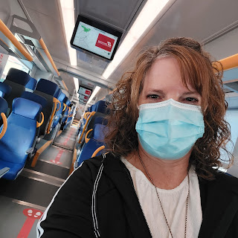

Man, was I glad to see Kylie and know that I was with family now.

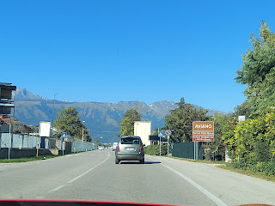

We met up with Benson at a gas station - he had been getting a haircut on base.

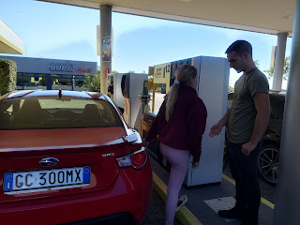

I switched vehicles and Benson did his darn tootin' best to get me on base. Apparently there is a temporary policy in place right now that says I had to have paperwork filled out and approved a minimum of 30 days prior to my visit just to go on the base. EVEN IF I already have a military ID. My friend said it probably has something to do with the closing up shop of the US military in Afghanistan and all the refugees fleeing the country to other places. The military would inevitably have more heightened security at a foreign US base, just to be safe.

Again, the view of those Dolomites. Just gorgeous to look at them every single day.

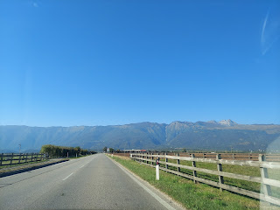

We went back to Benson and Kylie's house briefly, and I got to meet the newest member of their household: Keno. He is the same breed as Mocha (Akita) and will eventually be her mate. :)

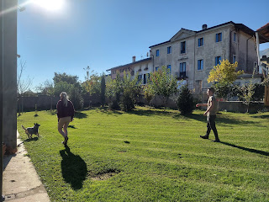

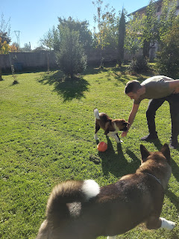

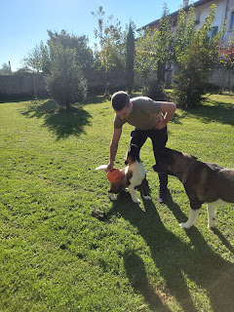

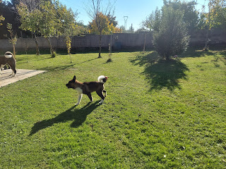

In the afternoon, Amber texted me asking if they could call me because Gwen missed me and wanted to talk to me. :) My heart . . .

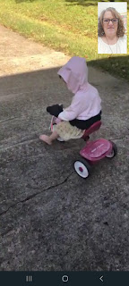

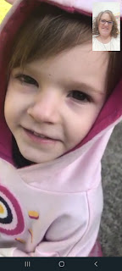

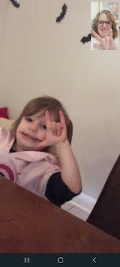

It was the day before her 4th birthday and she was happy to charge into her last day of being 3. Starting with some toast for breakfast with Nutella on it.

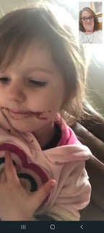

She even blew me some kisses that I was able to skillfully catch clear over in Italy! :) And I blew some back to her as well.

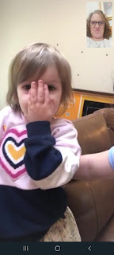

Amber told me that Gwen often asks, "When is Mimi coming to our house?" One day, she even asked, "Does Mimi know

how

to get to our house?" Amber reminded her that I drove with them all the way to their house in Louisiana - from Idaho. Gwen's frustrated response was: "Well then why doesn't she just come here then?!!"

Tuesday:

While Gwen was busy turning 4, I went on a walk to orientate myself to the area I'd be staying in for my last week overseas. I decided I'd just start out by heading to the nearest little village and see what I could find.

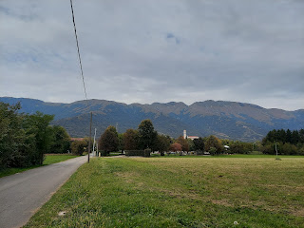

I passed Benson and Kylie's house just up the road. Such a cute place! They've done such a good job taking care of it - the house and the yard both.

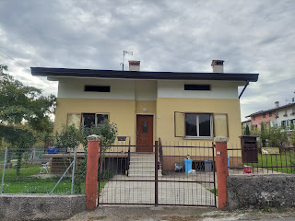

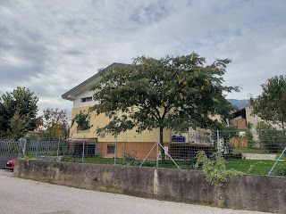

Here are some of the sights from my walk around Marsure. I kept my eyes on the old church from wherever I was, and aimed to find a way to end up there.

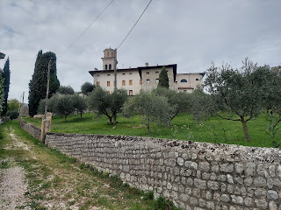

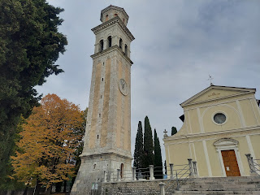

As expected, the church is very old. It was first built in 1494, with a few additions and modifications over the next few centuries.

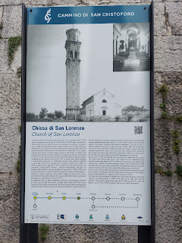

The lane behind the church.

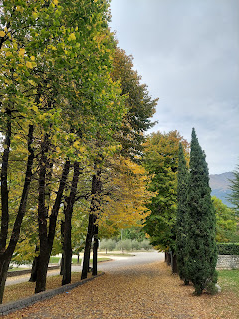

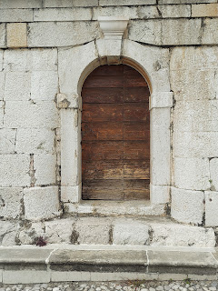

The view from where the church stands today is just lovely.

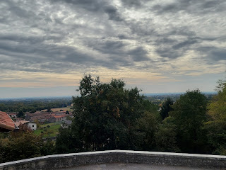

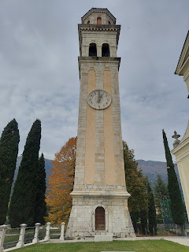

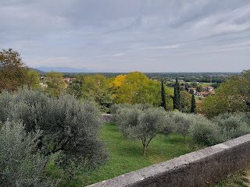

From there, I decided to see what else I could see.

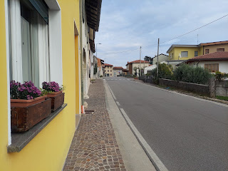

I found a children's school, or maybe it's a preschool.

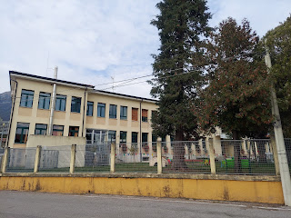

I found this outer burr that once held a chestnut inside. I think it's amusing because it reminds me of either a lion's mouth open super wide, or perhaps even a Muppet mouth from one of my favorite childhood shows, The Muppet Show. Can't you just picture one of them singing as loud as they can with their mouth open this wide?

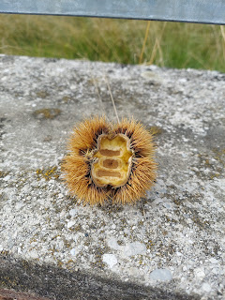

As I came around the corner, I heard a rooster crowing. At least, he was TRYING to crow. It was hilarious to listen to him because it sounded like he had a hairball in his throat or something.

Video of the rooster: (15 seconds)

https://photos.app.goo.gl/Ykr2AmDN6KdJVyvU6

Again, I will never get tired of the Dolomites.

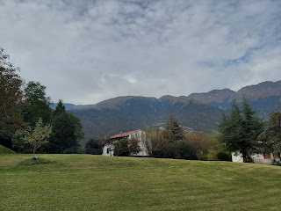

Later in the afternoon, the host where I'm staying took me around town to try to get an appointment set for a covid test before I fly back to the United States. We had a very difficult time and couldn't get ANY appointment. Everything was full, everywhere we went. Over here, the pharmacies are where you typically get the testing done. "Mama Lorraina", as she calls herself, was tireless in her efforts to help me. She knew how important this was, and since she is a native Italian, she acted as my liaison everywhere we went. She was my advocate when I couldn't speak for myself, and I appreciate that so much! Each time we got back to the car, anything I didn't understand we would use our phones and the Google translate app to communicate. She spent close to an hour driving me around and I am so grateful!

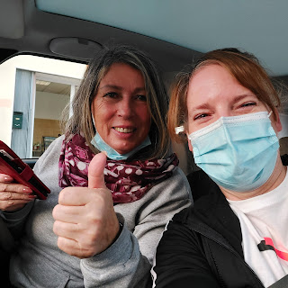

I found it so amusing that the phrase in English "rapid antigen" test - translates to this in Italian. (see below) I could not for the longest time figure out why she kept saying "tamponi" over and over! And on google translate, it would show up as "tampon". LOL

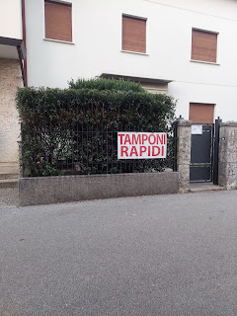

The one lead we got from one of the pharmacies was to go online and visit a website - the Nutrizione e Prevenzione website. When we got back to the house, feeling defeated - along with me feeling very stressed out now (how would I ever get home if I couldn't get a covid test?!), I decided to go up to my room and say a prayer.

After my prayer, I went online to the website that was recommended. Voila! My phone translated everything to English for me, and I saw that there were several appointments available for Saturday, which is the day I needed. Could it really be this easy? I set the appointment, noting that the cost was 45 euros, and then I ran downstairs to let Lorraina know.

I showed her the email that I got, which confirmed the appointment, and also had instructions in both Italian and English. She marveled that it was so easy, after the frustrating time we just had in town. But I knew that my prayer had been answered. It was a Hallelujah moment for sure! Now I could relax for the rest of the week, knowing that I was set for Saturday. :)

For dinner that night, I walked for about 20 minutes into Marsure, to eat at this lovely restaurant, the Due Lune. I ordered shrimp and a salad.

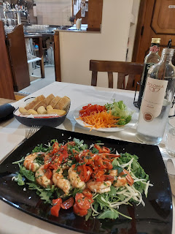

For dessert, I chose the tastiest thing I may have ever eaten!! It's a cute little pistachio cheesecake, with fresh pistachios from the Amalfi Coast, I was told. It was amazing!!

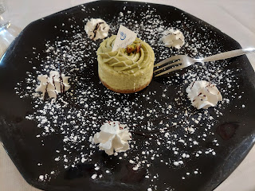

Wednesday:

I decided to go on a hike that Benson had suggested to me. There is a beautiful old church, known as the Santuario Della Madonna del Monte. You can see it in a lot of the photos that I have taken, ones where you can see the mountains above Aviano. Just look at the foothills and you'll see the dome-shaped sanctuary.

I just love the vines and plant-life that attaches itself to the old buildings over here.

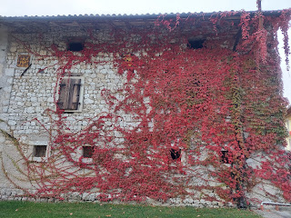

Part of my hike involved walking down this highway for a bit. It's always a little nerve-wracking when cars are driving so fast and I don't have much room to get out of the way.

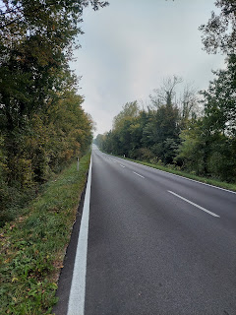

At one point I saw a shortcut, at least what I assumed was a shortcut, so I took it. I turned out to be right. It was much quieter in here, and safer away from the highway traffic.

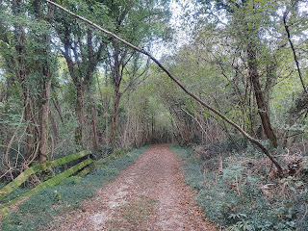

I went through a tiny village and then up a steady incline involving several switchbacks. And I found me a freshly hatched chestnut to take home to Idaho. :)

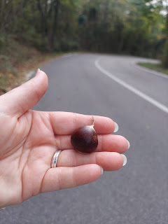

Eventually, I arrived at the final section of the trail up to the church. This was a purposeful walk, with several mosaic art displays along the way, meant for you to stop and be contemplative on your way up to the church.

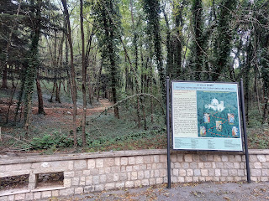

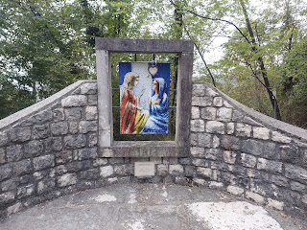

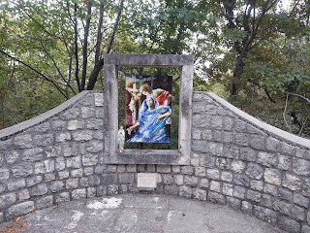

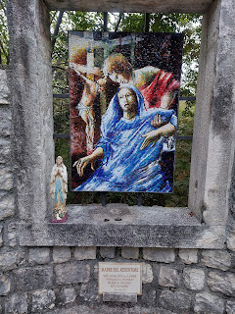

Finally, I arrived at the last set of stairs.

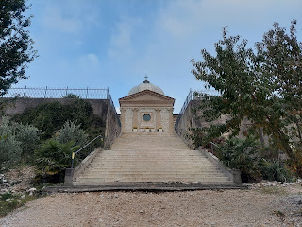

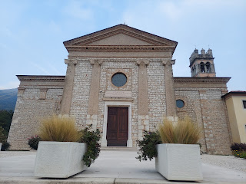

The view of the valley below was just gorgeous!

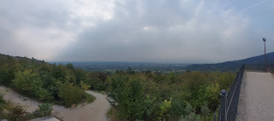

And someone had lovingly planted a TON of flowers all around the church grounds. It was so peaceful and beautiful.

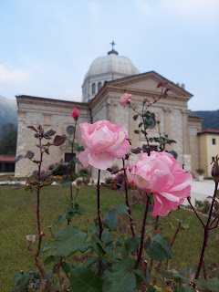

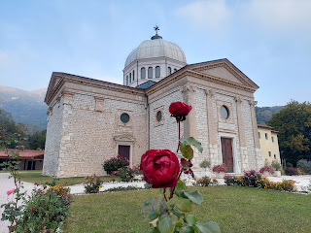

I saw someone go inside at one point, which I had never considered. I put on my mask and followed the girl in. There were several beautiful and ornate altars, where you could light a candle for a loved one (for a fee), and I think the priests will pray for them.

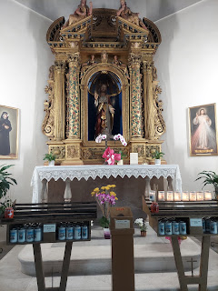

This is the very old, and original bell that used to hang up in the tower. Below you will find more information about the bell (in Italian.)

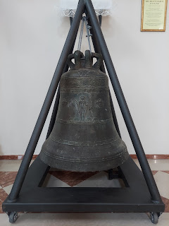

Campana fusa nel 1680 = Bell cast in 1680.

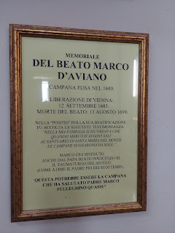

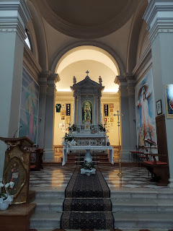

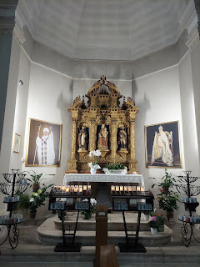

More flowers and more wandering the paths outside.

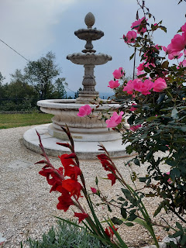

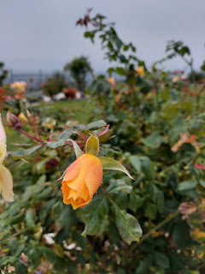

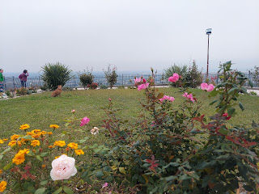

And then back down the stairs and back down the mountain. I hadn't noticed this cross going up the steps when I first arrived. Maybe because my focus was all on the church up above me.

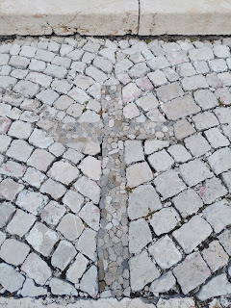

Back through the tiny village.

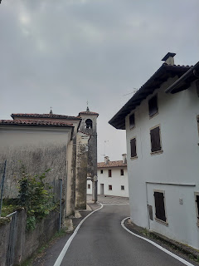

And then I walked back along the highway. Okay, so something I've noticed in Italy is everyone has these TINY little garbage cans, or buckets. How does anyone only have that much garbage? I asked Kylie about it and she said that there are several different types of garbage containers, and each one has a designated day of the week for pick-up. Maybe plastic is picked up one day, other recyclables on another day, and actual waste on another day. Still, they are just so tiny!!

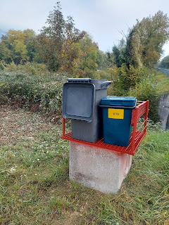

It took me about one hour to get up to the church, but it only took me about 30 minutes to get all the way back. I was quite sweaty by the time I got back to my lodging.

A little later in the day, Kylie messaged me asking if I could help with Benson's dress blue uniform. Apparently, they learned in the middle of the night during Benson's shift that he would be having an impromptu inspection on Friday. He didn't have the stripes sewn on his jacket sleeves yet, so they asked for my help. I was very happy to do it!

First, Kylie dropped off a sewing kit that she had borrowed. Then, a short time later, Benson dropped off both his dress blues and an inspection-worthy set that belonged to a friend - so that I could have a reference.

Before:

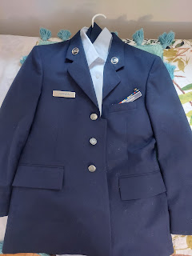

The most critical decision was where to place the patches. I had horrible internet at this place, and couldn't find the information that I needed. So I called Scott to have him look it up for me. Usually the patches are supposed to be so many inches from the shoulder, or the pocket, or wherever, and I didn't want to mess this up for my child.

Scott found out that it just needed to be centered between the shoulder and the elbow, and then centered between the bicep and the tricep areas of the sleeves. Using Benson's friend's jacket as my model, and using a piece of paper to make marks on for measuring, I pinned it in place.

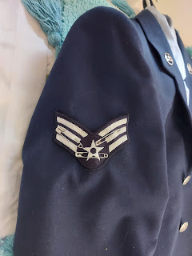

It took me a long time to get the first one sewn on, mainly because I was trying to be so careful. I also struggled with trying to only catch the outer fabric with my sewing needle, and not grab the lining on the inside of the sleeve.

Once I got it sewn on an hour later, I tried it on to double check that it looked okay.

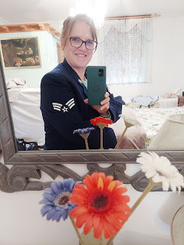

The second patch went on much faster. And voila! I did it. Later I found out that his superiors wouldn't be going around with a measuring tape to check everyone's patches, ha ha. Well, at least we knew it looked pretty good for any future inspections as well. My goal is to do the best job possible, not to just "get by." And his inspection went just fine. Whew!

After:

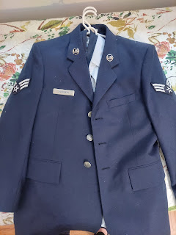

Thursday:

This was a rainy day, but I wanted to get out for a little walk to the neighborhood market, called the Coop. Over here, they pronounce it more like it rhymes with "loop", or in Switzerland it was pronounced more like "cope".

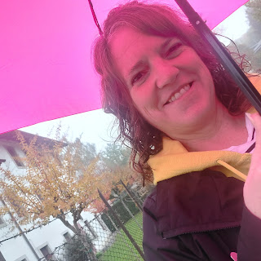

They have a lot of prosciutto in Italy. And they put it on everything. Pizza. Sandwiches and paninis. Salad. Literally everything. Or even just plain for breakfast, with some sliced cheese or other lunch meats.

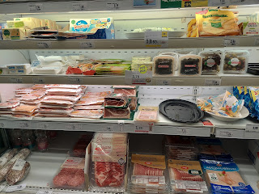

A nice variety of cheeses, but nothing like Switzerland - as far as quantity of varieties. :)

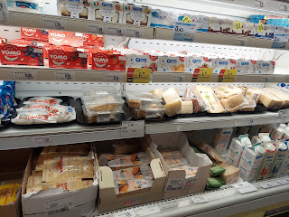

I realized too late that I should have taken a better picture of the produce that shows the prices. Oh well. Sorry.

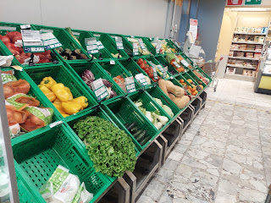

Frozen goods.

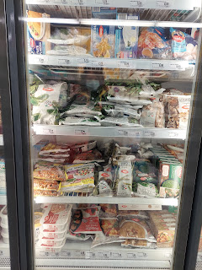

And every variety of pasta that you've never heard of!!

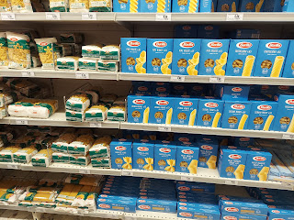

On my way home, I passed Kylie and Keno out in their yard. Kylie is really good at spending individual time with the doggies, making sure they're getting attention and instruction. Especially Keno, since he's the youngest at 4 months old.

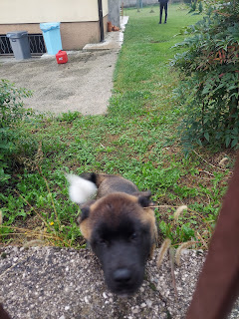

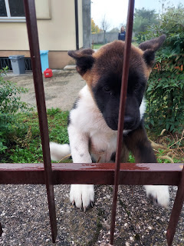

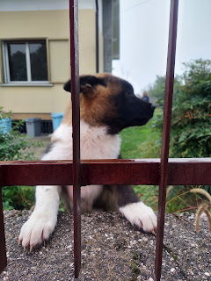

Friday:

After being cooped up for waaay too many hours on Thursday, . . . Friday with its sunshiny invitation beckoned me to go for another walkabout. This time I decided to walk into Aviano for the first time and explore the city. It takes about 35 minutes to get there.

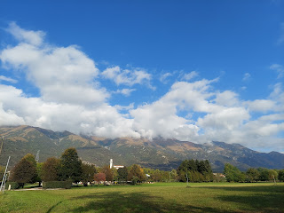

You can see the Santuario Della Madonna in the foothills below. I always kept my eye on it as I walked to different places. Once you've been up there, it's now a permanent landmark from wherever you are below.

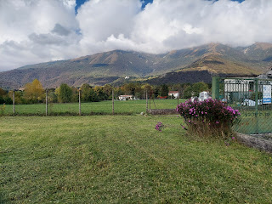

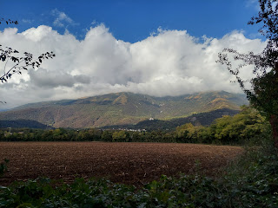

I've been trying to take pictures of various gardens throughout Europe for my sister, Charmaine, who is a master gardener. This one caught my eye because of the flexibility to provide some protection for your plants, or just allow them to have some fresh air, depending on the weather.

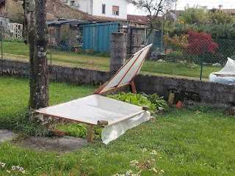

Aviano has a nice square, or piazza in the center of town. I saw restaurants and shops all over the place, and plenty of people out and about for it only being mid-day.

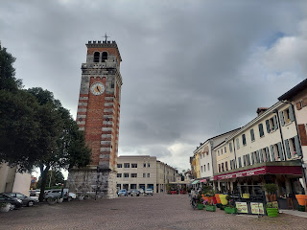

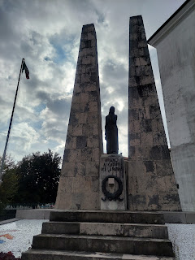

I chose a restaurant for lunch by using my phone, and walked over to Marko's Gyros. It just happened to be across the street from the edge of the Air Force Base.

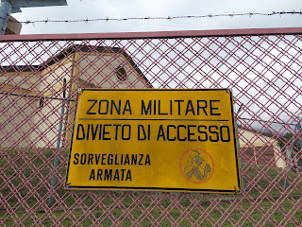

It was a very tasty lunch and I'm glad I chose that place! I got a gyro and fries. Then I went for more of my walk. Here is a view of the mountains and the clouds over the base. The trees were lovely with fall colors everywhere.

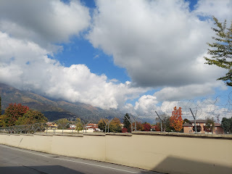

After a while of meandering, I decided it was time for some gelato. Next door to the shop was this little real estate office, with a few listings on the window.

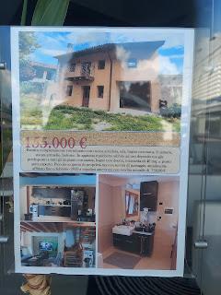

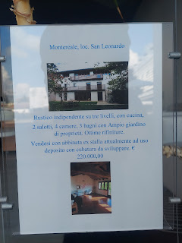

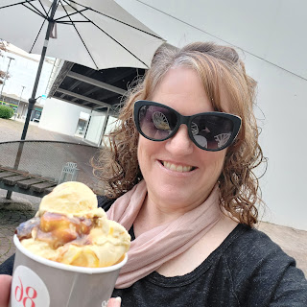

Something I learned from Luigi, one of the hosts where I stayed in Aviano, was that in Italy the taxes on property are ridiculous! He said if you bought a house 15 years ago for $160,000, today it would only be worth maybe $60,000. Nobody wants to own a house or any land in Italy because they tax you so heavily! How sad! He also told me that he quit his architectural drafting job that he had for 18 years because he lost 72% of his earnings to taxes!! That's crazy! He took a lower paying job, working at a manufacturing plant 20 km away, doing a graveyard shift, just so he could take home a larger percentage of his earnings. Wow.

I guess we need to be grateful for some of the things we take for granted in the United States.

There was a cute little nature park close by, so I wandered around it, all the while thinking of my granddaughters and how much they would love this place.

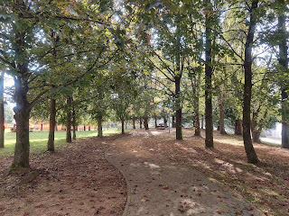

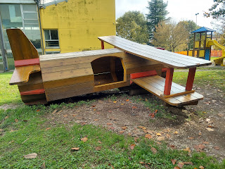

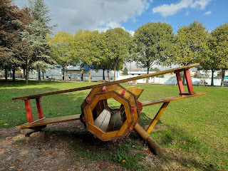

Across the street from the park was a well-designed and landscaped back yard, complete with a small pond and a little winding stream. This would be a huge project if I ever decided to do something like this, but it would be a delightful place for my grandchildren to play.

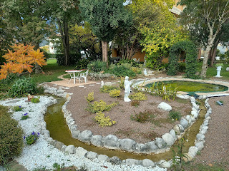

I gathered a few of the most colorful fall leaves that I found on the ground, and took a souvenir photo.

Autumn in Aviano.

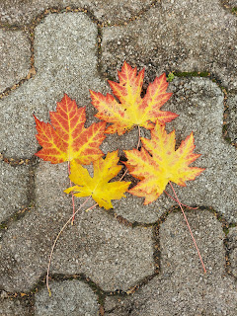

On the walk back to my room, I stopped to smell the roses. Everyone seems to have roses here, and they are all so beautiful.

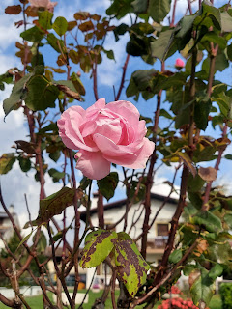

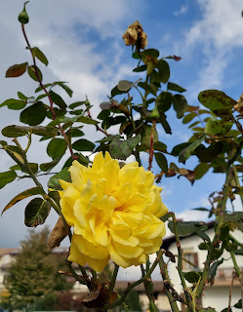

Most all of the houses have protective shutters, in addition to the exterior windows, and many people set out colorful flower pots on their window sills. It's very cheery for all the passersby.

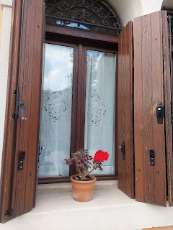

At first, I couldn't identify this fruit that I saw growing on several trees. Later, I looked it up, and I'm pretty sure the fruit is quince.

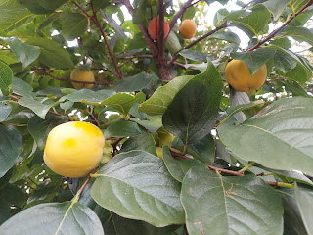

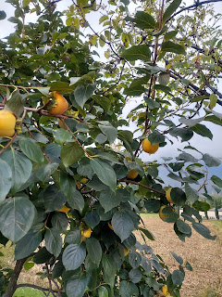

The mountains to my left looked very boding, and I knew a rainstorm was coming.

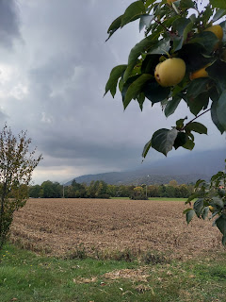

But I couldn't resist one more detour. This tree-lined lane looked so inviting, I decided to see what was at the other end. I'm so glad I did.

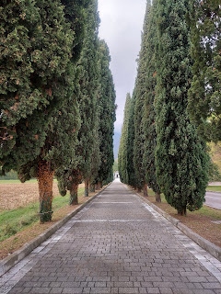

It was an Italian Cemetery!

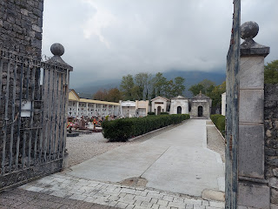

It seems that a lot of people choose cremation because the bulk of the memorials were made for cremated remains. But the cemetery itself was incredibly beautiful. It was also quite large!

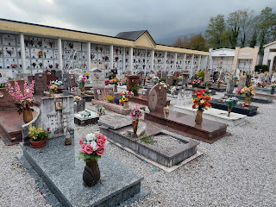

What a phenomenal tradition they have here of identifying each person with their vital information, as well as having PHOTOS of the loved ones who have passed!!! That is just tremendous!!! I'm not just talking about the occasional headstone or memorial having photos. They ALL did!

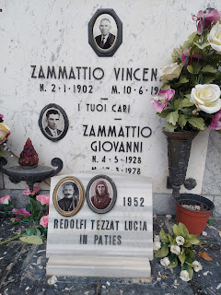

In the middle of the grounds is a set of stairs leading up to a stone gazebo that overlooks the entire cemetery.

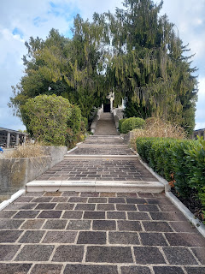

On my way up the stairs, I admired and appreciated this sweet older couple that were lovingly washing several memorials, even while it was beginning to sprinkle.

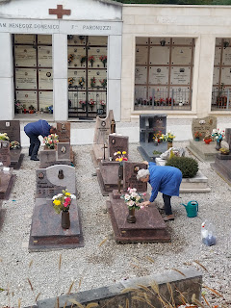

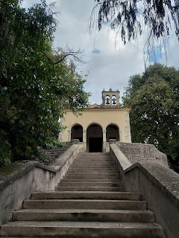

Here is the view from the gazebo.

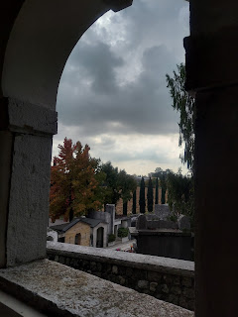

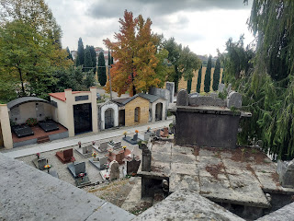

I'm glad I stopped to explore the cemetery. It just gives me a little more perspective on how other cultures treat (and revere) their dead. From here, I just hurried on to get home before it started pouring. I had a rain jacket, but I had not brought my umbrella. I thought it was going to rain much later in the day, so I had not brought it with me.

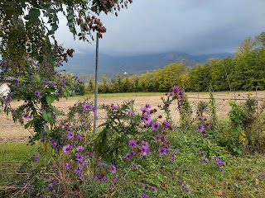

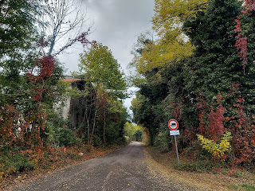

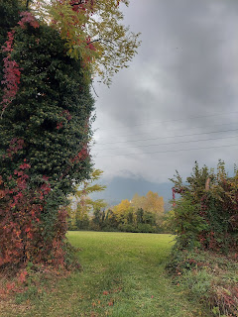

In the 4 hours that I spent walking to and from, and all throughout Aviano, these were my stats.

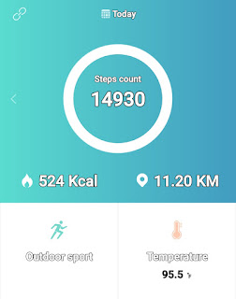

Later that evening, I went out for one more walk: to a restaurant for dinner. It was another 20 minute walk.

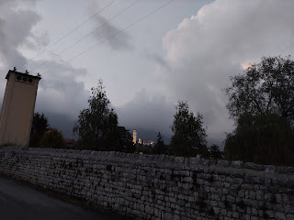

This time I ordered shrimp and cuttlefish, with some grilled vegetables on the side.

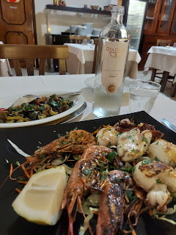

Saturday:

This was a very important day - I went to get my Covid Test so that I could GO HOME!! My hosts at the B&B, Luigi and Lorraina, drove me over to Pordenone at the scheduled time. Everything went very smoothly, which again - I was in awe, scratching my head. How could it really be that smooth?? But it was!

We got there extra early, so we found a nearby cafe where they could get their morning latte, and I just got a cup of water. Soon, we walked back over to the medical office building and waited for them to call my name out. I paid the 45 euros, sat in the chair and had them shove a 2-foot swab up my nose and twirl it around for an hour, then I waited about 5 minutes for the results. Results were negative by the way, ha ha. They gave me a certified paper, showing the results, and then we drove back to Aviano. Hooray!

This is how I felt after that nose-swabbing.

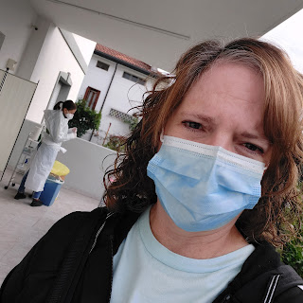

I got to spend about 40 minutes with Benson and Kylie for the day. And most of that time was spent washing Mocha and Keno in the tub, and then letting them run around in the back yard to dry off a bit.

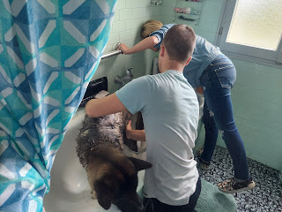

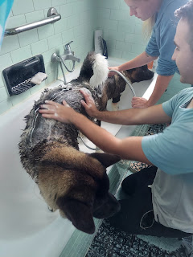

This stunning tree was right next to my B&B. I want a tree like this in my yard back home.

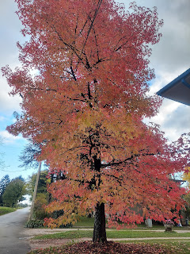

I walked to a nearby pub to get some dinner. For 8 euros, you can get a ginormous panini just like this for yourself. Holy cow - It could easily feed about 4 people!! I could hardly fit it in my mouth, and I only ate about 1/4 of it and had to leave the rest, since I don't have access to a fridge.

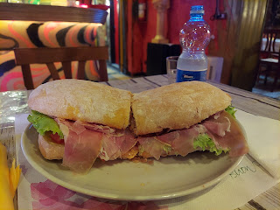

Sunday:

After having a solo brunch at the restaurant down the road, I was finally able to spend some time with Benson and Kylie for the afternoon. We drove a short distance (maybe 30 minutes) to go see Lake Barcis. (pronounced Barchis) They brought Mocha along, so she was my back seat buddy. :)

Short video of driving through a tunnel alongside the Dolomites mountain range & trying to see the view once we came out of the tunnel, ha ha. (32 seconds)

https://photos.app.goo.gl/Q5k4uF2dFseUVTbs6

Once we arrived at Barcis, there is the most beautiful lake there, with trails all around it. We chose the trail that leads up to the glass overlook. It was about a 10 minute hike to get there. And it was absolutely gorgeous!!

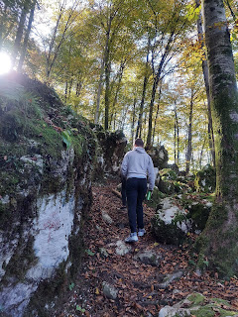

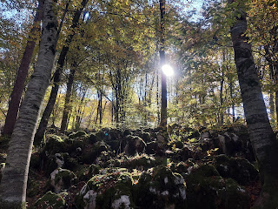

They stopped to pose Mocha for a picture. :)

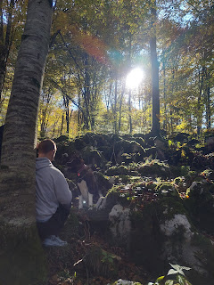

I love this photo. It really says a lot about them, their life and love for each other, and how they are heading into their future together as they prepare to have their first child. :)

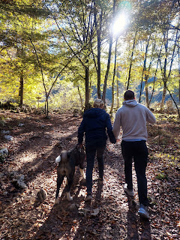

The reward at the end of this particular trail.

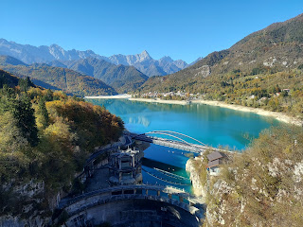

The viewing platform is made of glass. Thick and sturdy glass mind you.

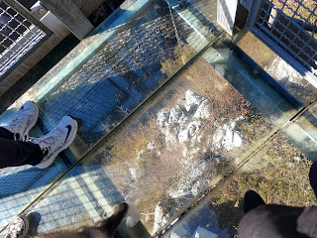

Short video of the area, including the dam: (10 seconds)

https://photos.app.goo.gl/XY3EqHQjiLhGp4gp8

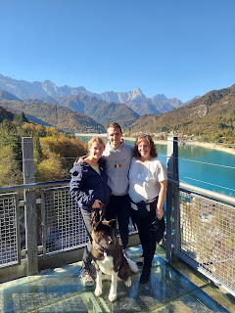

Even though the water level is low at the end of the year, you can still see how beautiful the teal color is.

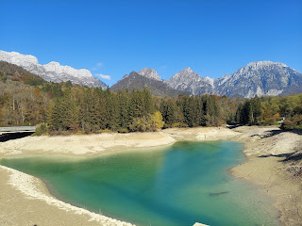

We drove a little further up the road to see what we could see. The panorama below is near the town of Cimolais.

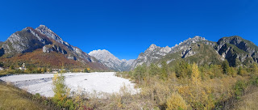

In this photo: see if you can find Benson. Good luck!!

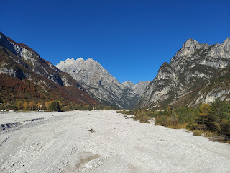

It was VERY cool to see the Dolomites, and especially to see it together with Benson and Kylie.

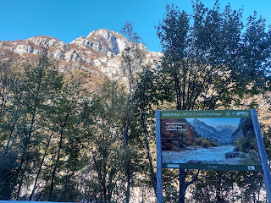

After we drove back to Aviano, we switched cars, used the potty, and then Benson drove me to the Venice Airport, about an hour south. I was sad that we didn't get very much time together this past week, especially after I came all this way. But I'm glad that I got to see them a little here and a little there, and to know that they are doing okay.

It felt really good to know that I am on my way home!! After a MONTH of being gone. WOW.

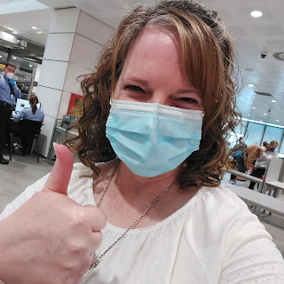

Goodbye Venice.

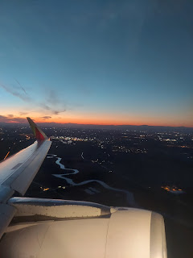

Hello Lisbon.

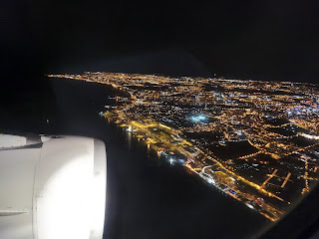

And soon to be . . . Hello America!!